

Dr. Helen, Bradley inc.
2018-12-28
Dr. Bradley
Unit 2310 Box 1872, DPO AP 58527
Phone: 5118078901
Fax: 6491307221

Re: Angel, Faulkner
PHN: 9723525789
Birthdate: 31-Oct-1945
Address: 51051 Serrano Club Apt. 893, Youngfurt, PA 20758
Patient number: 3503532248

To Whom It May Concern:

This is a medical letter to state the above patient is pregnant with expected delivery date of 26-Jun-2025. Hoping this information is satisfactory for your requirements.

Thank you.

Sincerely,
Dr. Helen, Bradley
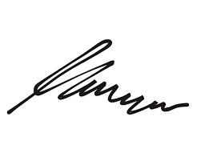
FRCS© NCMP
Clinical Assistant Professor, UBC
Department of Obstetrics and Gynecology SMH

